Important Information

**ES PERFMON**

User Manual

**Version 0.0.5 | ref.no tbd | Revision A0**



Information in this document is subject to change without notice and does not represent a commitment on the part of DataDirect Networks, Inc. No part of this manual may be reproduced or transmitted in any form or by any means, electronic or mechanical, including photocopying and recording, for any purpose other than the purchaser’s personal use without the written permission of DataDirect Networks, Inc.

**© 2018 DataDirect Networks, Inc. All rights reserved.**

DataDirect Networks, the DataDirect Networks logo, DDN, DirectMon, Enterprise Fusion Architecture, EFA, ES7K, ES12K, ES14K, EXAScaler, GRIDScaler, GS7K, GS12K, GS14K, IME, IME14K, Infinite Memory Engine, Information in Motion, In-Storage Processing, MEDIAScaler, NAS Scaler, NoFS, ObjectAssure, ReACT, SFA, SFA 10000 Storage Fusion Architecture, SFA10K, SFA12K, SFA14K, SFA7700, SFX, Storage Fusion Architecture, Storage Fusion Fabric, Storage Fusion Xcelerator, SwiftCluster, WOS, the WOS logo are registered trademarks or trademarks of DataDirect Networks, Inc. All other brand and product names are trademarks of their respective holders.

DataDirect Networks makes no warranties, express or implied, including without limitation the implied warranties of merchantability and fitness for a particular purpose of any products or software. DataDirect Networks does not warrant, guarantee or make any representations regarding the use or the results of the use of any products or software in terms of correctness, accuracy, reliability, or otherwise. The entire risk as to the results and performance of the product and software are assumed by you. The exclusion of implied warranties is not permitted by some jurisdictions; this exclusion may not apply to you.

In no event will DataDirect Networks, their directors, officers, employees, or agents (collectively DataDirect Networks) be liable to you for any consequential, incidental, or indirect damages, including damages for loss of business profits, business interruption, loss of business information, and the like, arising out of the use or inability to use any DataDirect product or software even if DataDirect Networks has been advised of the possibility of such damages by you. Because some jurisdictions do not allow the exclusion or limitation of liability for consequential or incidental damages, these limitations may not apply to you. DataDirect Networks liability to you for actual damages from any cause whatsoever, and regardless of the form of the action (whether in contract, tort including negligence, product liability or otherwise), is limited to the sum you paid for the DataDirect product or software.

All Products cited in this document are subject to DDN’s Limited Warranty Statement and, where applicable, the terms of DDN’s End User Software License Agreement (EULA).

The cited documents are available at: <http://www.ddn.com/support/policies/>

For archived versions of either document, please contact DDN.

October 2017

Table of Contents

1 Introduction to DDN EXAScaler Performance Monitoring System 7

1.1 Terminology 7

1.2 collectd plugins of DDN 7

2 Installation Requirements 9

2.1 Installation Server 9

2.2 Monitoring Server 9

2.3 Monitoring Client 9

3 Installation Process 10

3.1 Preparing the Installation Server 10

3.2 Updating the configuration 10

3.3 Running installation on the cluster 12

3.4 Accessing the Monitoring Web Page 13

4 Dashboards 14

4.1 Cluster Status Dashboard 14

4.2 Lustre Status Dashboard 15

4.3 Server Statistics 37

4.4 SFA Physical Disk Dashboard 41

4.5 SFA Virtual Disk Dashboard 44

5 Stress Testing 47

5.1 Installing stress2 RPM on collectd Client 47

5.2 Updating ConfigurationFile of Collectd Client 47

5.3 Start Testing 48

6 Troubleshooting 51

List of Figures

Figure 1: Grafana Login Web Page 13

Figure 2: Home Dashboard 14

Figure 3: Cluster Status Dashboard 15

Figure 4: Lustre Statistics Dashboard 15

Figure 5: Free Capacity in Total Panel 16

Figure 6: Used Capacity in Total Panel 16

Figure 7: Free Capacity per OST Panel 17

Figure 8: Used Capacity per OST Panel 17

Figure 9: Used Capacity per User Panel 18

Figure 10: Used Capacity per Group Panel 18

Figure 11: Free Inode Number in Total Panel 19

Figure 12: Used Inode Number in Total Panel 19

**Figure 13: Free Inode Number per MDT Panel** 20

Figure 14: Used Inode Number per User Panel 20

Figure 15: Used Inode Number Per Group Panel 21

Figure 16: Used Inode Number per MDT Panel 21

Figure 17: I/O Throughput in Total Panel 22

Figure 18: I/O Throughput per OST Panel 22

Figure 19: Write Throughput per OST Panel 23

Figure 20: Read Throughput per OST Panel 23

Figure 21: Metadata Operation Rate in Total Panel 24

Figure 22: Metadata Operation Rate Per MDT Panel 24

Figure 23: Metadata Operation Rate per Client Panel 25

Figure 24: Metadata Operation Rate per Type Panel 25

Figure 25: Write Bulk RPC Rate per Size 26

Figure 26: Size Distribution of Write Bulk RPC Panel 26

Figure 27: Read Bulk RPC Rate per Size Panel 27

Figure 28: Size Distribution of Read Bulk RPC Panel 27

Figure 29: Distribution of Discontinuous Pages in Each Write I/O Panel 28

Figure 30: Distribution of Discontinuous Pages in Each Read I/O Panel 28

Figure 31: Distribution of Discontinuous Blocks in Each Write I/O Panel 29

Figure 32: Distribution of Discontinuous Blocks in Each Read I/O Panel 29

Figure 33: Distribution of Fragments in Each Write I/O Panel 30

Figure 34: Distribution of Fragments in Each Read I/O Panel 30

Figure 35: Distribution of in-flight Write I/O Number when Starting Each Write I/O Panel 31

Figure 36: Distribution of in-flight Read I/O Number when Starting Each Read I/O Panel 31

Figure 37: Distribution of Write I/O Time Panel 32

Figure 38: Distribution of Read I/O Time Panel 32

Figure 39: Distribution of Write I/O size on Disk Panel 33

Figure 40: Distribution of Read I/O Size on Disk Panel 33

Figure 41: Write Throughput per Client Panel 34

Figure 42: Read Throughput per Client Panel 34

Figure 43: I/O Throughput per Job Panel 35

Figure 44: Write Throughput per Job Panel 35

Figure 45: Read Throughput per Job Panel 36

Figure 46: Metadata Performance per Job Panel 36

Figure 47: Server Statistics Dashboard 37

Figure 48: CPU Usage Panel 37

Figure 49: Memory Usage Panel 38

Figure 50: Disk Write Rate Panel 38

Figure 51: Disk Read Rate Panel 39

Figure 52: Disk Usage on Root Panel 39

Figure 53: Load Panel 40

Figure 54: Uptime Panel 40

Figure 55: User Panel 40

Figure 56: Temperature Panel 41

Figure 57: SFA Physical Disk Dashboard 41

Figure 58: I/O Performance on Physical Disk Panel 41

Figure 59: IOPS on Physical Disk Panel 42

Figure 60: Bytes per I/O on Physical Disk Panel 42

Figure 61: Write Performance on Physical Disk Panel 43

Figure 62: Write I/O Size Samples on Physical Disk Panel 43

Figure 63: Write Latency Samples on Physical Disk Panel 43

Figure 64: SFA Virtual Disk Dashboard 44

Figure 65: I/O Performance on Virtual Disk Panel 44

Figure 66: I/O Operations per Second on Virtual Disk Panel 45

Figure 67: Bytes per I/O on Virtual Disk Panel 45

Figure 68: Write Performance on Virtual Disk Panel 45

Figure 69: Write I/O Size Samples on Virtual Disk Panel 46

Figure 70: Write Latency Samples on Virtual Disk Panel 46

Figure 71：Influxdb Query Time 50

Figure 72：Read throughput per Job stress testing 50

# Introduction to DDN EXAScaler Performance Monitoring System

*ES PERFMON* is a monitoring system that can collect system statistics of DDN EXAScaler for performance monitoring and analysis. It is based on multiple widely used open-source software. Some extra plugins have been developed by DDN for enhancement.

One of the main components of *ES PERFMON* is **сollectd**. **collectd** is a daemon, which collects system performance statistics periodically and provides mechanisms to store the values in a variety of ways. *ES PERFMON* is based on the open-source **collectd**, yet includes more plugins, such as Lustre, GPFS, Ganglia, Nagios, Stress, Zabbix and so on.

## Terminology

|  |  |
| --- | --- |
| **ES PERFMON** | Abbreviation for DDN EXAScaler Performance Monitoring System. |
| **DDN EXAScaler** | Software stack developed by DDN to overcome the toughest storage and data management challenges in extreme, data-intensive environments. |
| **Installation Server** | The server on which the installation process is triggered. |
| **Monitoring Server** | The server on which the database (Influxdb) and web server (Grafana) of the monitoring system will run. |
| **Monitoring Client(s)** | The hosts, from which the monitoring system will collect metrics from. The metrics includes information about CPU, memory, Lustre, SFA storage, and so on. A collectd daemon will run on each monitoring client. |
| **DDN IME** | DDN’s Infinite Memory Engine (IME) is a flash-native, software-defined, storage cache that streamlines application IO, eliminating system bottlenecks. |
| **Lustre** | The Lustrefile system is an open-source, parallel file system that supports many requirements of leadership class HPC simulation environments. |
| **OST** | The *Object Storage Target(OST)* of *Lustre* is the storage target that store the file data objects. |
| **OSS** | The *Object Storage Server(OSS)* of *Lustre* is the server that manage the *Object Storage Target*. |
| **MDT** | The *Metadata Target(MDT)* of *Lustre* is the storage target that stores the file metadata. |
| **MDS** | The *Metadata Servers(MDS)* of *Lustre* is the server that provides metadata services for a file system and manages one or multiple Metadata Target (MDT). |

## collectd plugins of DDN

Several additional plugins are added to **collectd** in ES PERFMON to support various functions.

* **Filedata plugin**: The **Filedata** plugin is able to collect data by reading and parsing a set of files. An XML-formatted definition file is required for the **Filedata** plugin to understand which files to read and how to parse these files. The most common usage of the **Filedata** plugin is to collect metrics through /proc interfaces of a running Lustre system.
* **Ganglia plugin**: The **Ganglia** plugin can send metrics collected by a **collectd** client daemon to Ganglia server.
* **GPFS plugin**: The **GPFS** plugin can collect performance information through mmpmon commands provided by GPFS. The GPFS plugin shares the same definition file format with the Filedata plugin. The configuration format of GPFS in collectd.conf is also similar to the **Filedata** plugin.
* **IME plugin**: The **IME** plugin can collect performance information from DDN IME. Like the GPFS plugin, the IME plugin shares the similar definition file format and configuration format with the **Filedata** plugin.
* **SSH plugin**: The **SSH** plugin is able to collect metrics by running commands on remote hosts by using SSH connections. The **SSH** plugin is used to collect metrics from DDN SFA Storage. Like the **GPFS** plugin and the **IME** plugin, the **SSH** plugin shares the similar definition file format and configuration format with the **Filedata** plugin.
* **Stress plugin**: The **Stress** plugin can push a large amount of metrics to server from **collectd** client in order to benchmark the performance of the collecting system under high pressure.
* **Zabbix plugin**: The Zabbix plugin is used to send metrics from **collectd** to Zabbix system.

# Installation Requirements

## Installation Server

* **OS distribution:** CentOS7/RHEL7
* **Free disk space:** > 500 MB. The Installation Server will save all installation logs to the /var/log/esmon_install directory, which requires some free disk space.
* **Network:** The Installation Server must be able to start SSH connections to the Monitoring Server and Monitoring Clients without a password prompt.
* **ES PERFMON ISO image:** The ES PERFMON ISO image must be available on the Installation Server.

## Monitoring Server

* **OS distribution:** CentOS7/RHEL7
* **Free disk space:** > 5 GB. Influxdb will be running on this server. More disk space is required to keep more data in Influxdb
* **Network:** SSHD should be running on the Monitoring Server. The Installation Server must be able to connect to the Monitoring Server without a password prompt.

## Monitoring Client

* **OS distribution:** CentOS7/RHEL7 or CentOS6/RHEL6
* **Free disk space:** > 200 MB. The installation server will save necessary RPMs in directory /var/log/esmon_install, which requires some free disk space.
* **Network:** SSHD should be running on the Monitoring Client. The Installation Server must be able to connect to the Monitoring Client without a password prompt.
* **EXAScaler version:** EXAScaler 2.x or EXAScaler 3.x

# Installation Process

## Preparing the Installation Server

1. Copy the ES PERFMON ISO image file to the Installation Server, for example, to /ISOs/esmon.iso.
2. Mount the ES PERFMON ISO image:

mount -o loop /ISOs/esmon.iso /media

1. On the Installation Server, back up old ES PERFMON configuration file, if there is any:

cp /etc/esmon_install.conf /etc/esmon_install.conf_backup

1. On the Installation Server, uninstall old ES PERFMON RPM, if there is any:

rpm -e esmon

1. Install the ES PERFMON RPM on the Installation Server:

rpm -ivh /media/RPMS/rhel7/esmon*.rpm

## Updating the configuration

After the ES PERFMON RPM has been installed on the Installation Server, update the configuration file /etc/esmon_install.conf, which includes all the necessary information for installation. Define the following parameters:

* **iso_path** — The path where the ES PERFMON ISO image is saved.
* **clients_reinstall** — Define whether to reinstall (**true**) ES PERFMON clients or not (**false**).
* **collect_interval** — The interval (in seconds) to collect data points on ES PERFMON clients.
* **continuous_query_interval** — The interval of continuous query. The value of **continuous_query_interval * collect_interval** is the real interval in seconds between two adjacent data points of each continuous query.
* **lustre_exp_ost** — Define whether to enable (**true**) or disable (**false**) metrics collection of export information of Lustre OST. To avoid a flood of metrics, this parameter is usually disabled in Lustre file systems with a large number of clients.
* **lustre_exp_mdt** — Define whether to enable (**true**) or disable (**false**) metrics collection of export information of Lustre MDT. To avoid a flood of metrics, this parameter is usually disabled in Lustre file systems with a large number of clients.
* **lustre_default_version** — The default Lustre version to use, if the Lustre RPMs installed on the ES PERFMON client is not the supported version. The current supported values of the parameter are **es2**, **es3**, **es4** and **error**. If the parameter **error** is configured, an error will be raised when an ES PERFMON client is using an unsupported Lustre version.
* In the section **ssh_hosts**, specify details necessary to log in to the Monitoring Server and to each Monitoring Client using SSH connection:
  + **host_id** — The unique ID of the host. Two hosts should not share the same **host_id**.
  + **hostname** — The host name to use when connecting to the host using SSH.
  + **ssh_identity_file** — The SSH key file used for connecting to the host. The parameter **ssh_identity_file** can be omitted if the default SSH identity file works.

Note: **host_id** and **hostname** can be different for a host, because there can be multiple ways to connect to the same host.

* In the section **client_hosts**, specify information about all of the hosts where ES PERFMON client packages should be installed and configured:
  + **host_id** — The unique ID of the host. Two hosts should not share the same **host_id**.
  + **lustre_oss** — Define whether to enable (**true**) or disable (**false**) metrics collection of Lustre OSS.
  + **lustre_mds** — Define whether to enable (**true**) or disable (**false**) metrics collection of Lustre MDS.
  + **ime** — Define whether to enable (**true**) or disable (**false**) metrics collection of DDN IME.
* In the section **server_hosts**, specify information about all of the hosts where ES PERFMON server packages should be installed and configured:
  + **host_id** — The unique ID of the host.
  + **reinstall** — Define whether to reinstall (**true**) ES PERFMON server or not (**false**). If the parameter is set to **false**, both **drop_database** and **erase_influxdb** will be ignored.
  + **drop_database** — If the parameter is set to **true**, the ES PERFMON database in Influxdb will be dropped. If the parameter is set to **false**, the ES PERFMON database in Influxdb will be kept as it is.
  + **erase_influxdb** — If the parameter is enabled (set to **true**), all the data and metadata of Influxdb will be completely erased. By enabling **erase_influxdb**, some corruption problems of Influxdb could be fixed. If the parameter is disabled (set to **false**), the data and metadata of Influxdb will not be completely erased.

**Important: erase_influxdb** and **drop_database** should only be enabled when the data in Influxdb is not needed anymore.

Below is an example of /etc/esmon_install.conf:

**Example:**

iso_path: /work/ISOs/esmon.iso

ssh_hosts:

- host_id: Monitoring-Server

hostname: Monitoring-Server

ssh_identity_file: /root/.ssh/id_rsa

- host_id: Monitoring-Client1

hostname: Monitoring-Client1

ssh_identity_file: /root/.ssh/id_rsa

- host_id: Monitoring-Client2

hostname: Monitoring-Client2

ssh_identity_file: /root/.ssh/id_rsa

client_hosts:

- host_id: Monitoring-Client1

lustre_oss: true

lustre_mds: true

ime: false

- host_id: Monitoring-Client2

lustre_oss: false

lustre_mds: true

ime: false

server_host:

- host_id: Monitoring-Server

drop_database: true

erase_influxdb: true

## Running installation on the cluster

After the */etc/esmon_install.conf* file has been updated correctly on the Installation Server, run the following command to start the installation on the cluster:

esmon_install

All the logs that are useful for debugging are saved under /var/log/esmon_install directory of the Installation Server.

Apart from installing ES PERFMON on a fresh system, the commandesmon_installcan also be used for upgrading an existing ES PERFMON system. The configuration file */etc/esmon_install.conf* should be backed up after installation of ES PERFMON in case of upgrading in the future.

**Important:** When upgrading an existing ES PERFMON system, **erase_influxdb** and **drop_database** should be disabled, unless the data or metadata in Influxdb is not needed anymore.

When installing or upgrading, esmon_installwill cleanup and install the default ES PERFMON dashboards of Grafana. Except for the default ES PERFMON dashboards, esmon_installwill not change any other existing dashboards of Grafana.

**Important:** Before upgrading an existing ES PERFMON system, all default ES PERFMON dashboards customized via a Grafana web page should be saved under different names, otherwise the modifications will be overwritten.

## Accessing the Monitoring Web Page

The Grafana service is started on the Monitoring Server automatically. The default HTTP port is 3000. A login web page will be shown through that port (see Figure 1 below). The default user and password are both “admin”.

Figure : Grafana Login Web Page

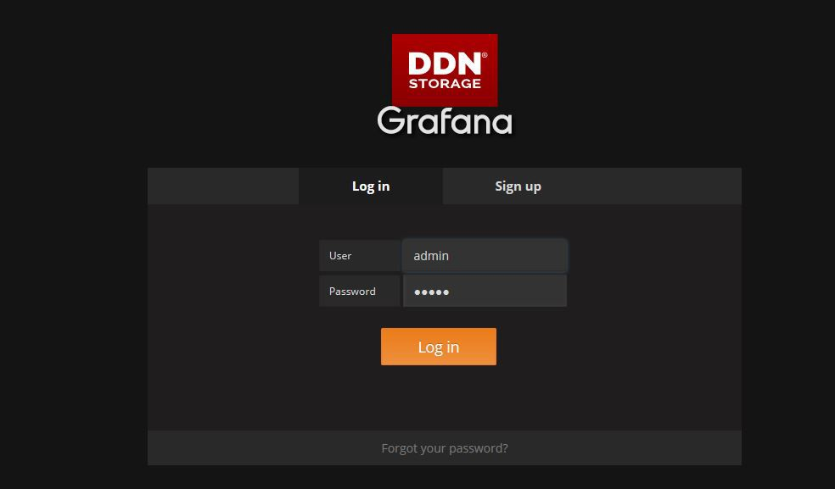

# Dashboards

From the Home dashboard (see Figure 2) different dashboards can be chosen to view different metrics collected by ES PERFMON.

Figure : Home Dashboard

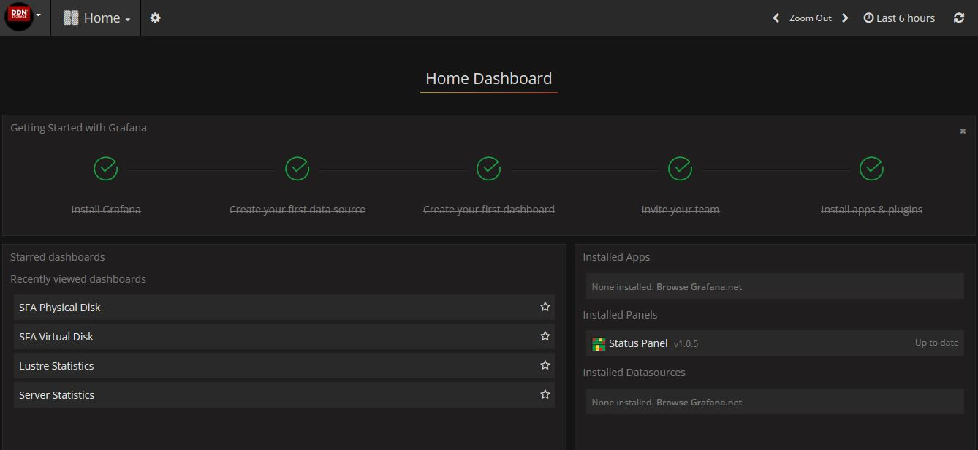

## Cluster Status Dashboard

The **Cluster Status** dashboard (see Figure 3 below) shows a summarized status of the servers in the cluster. The background color of panels show the servers’ working status:

* If the color of the panel is green, it means the server is under normal condition.
* If the color of the panel is yellow, it means the server is under warning status due to one or more of the following conditions:
  + Idle CPU is less than 20%
  + Load is higher than 5
  + Free memory is less than 1000 MiB
  + Free space of “/” is less than 10 GiB
* If the color of the panel is red, it means the server is under critical status due to one or more of the following conditions:
  + Idle CPU is less than 5%
  + Load is higher than 10
  + Free space of “/” is less than 1 GiB
  + Free memory is less than 100 MiB

Figure : Cluster Status Dashboard

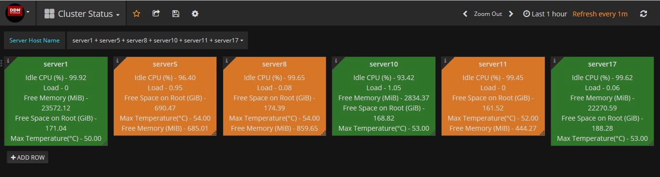

## Lustre Status Dashboard

The Lustre Statistics dashboard () shows metrics of Lustre file systems.

Figure : Lustre Statistics Dashboard

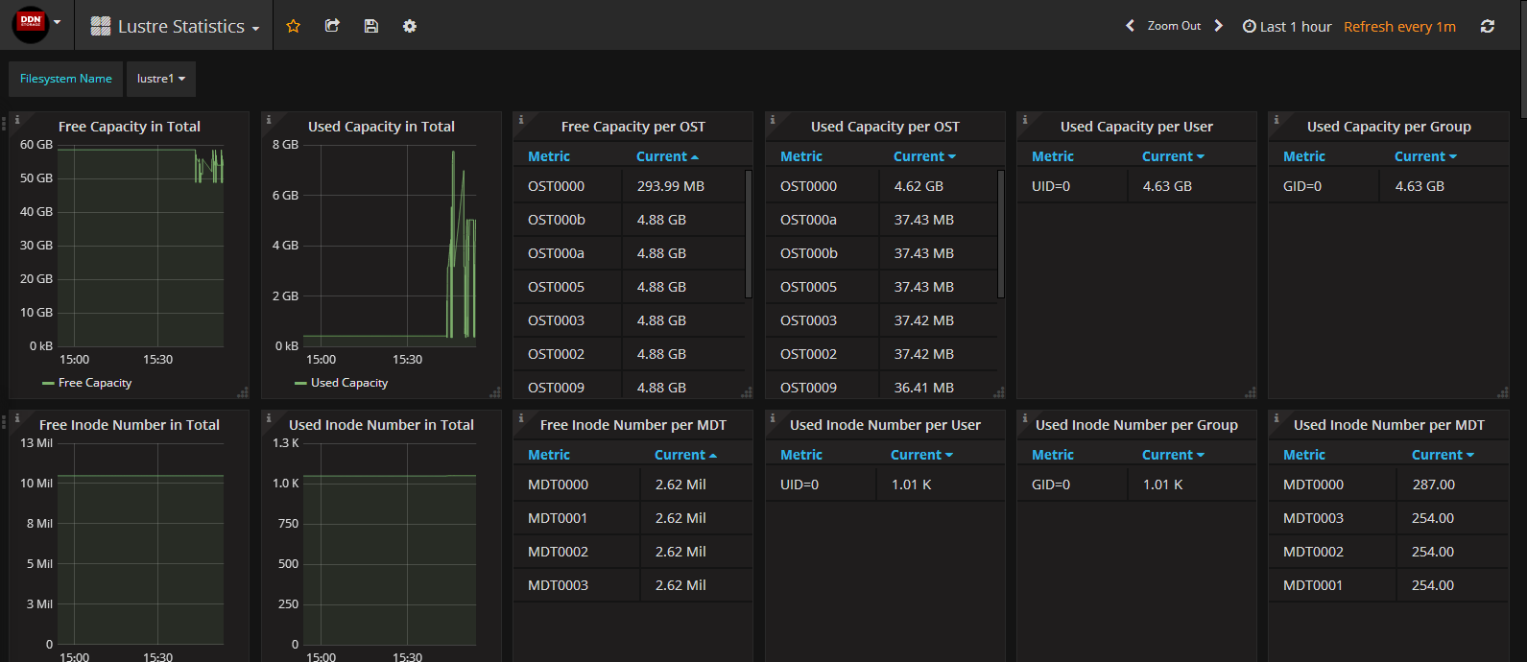

The following pictures are some of the panels in the **Lustre Statistics**dashboard.

* The **Free Capacity in Total** panel (Figure 5) shows how much free capacity remains in the Lustre filesystem. The test case used in the figure is running “dd if=/dev/zero of=/mnt/lustre/file bs=1M” from about 18:40, and it shows that the free capacity is being consumed at a speed of about 20MB/s.

Figure : Free Capacity in Total Panel

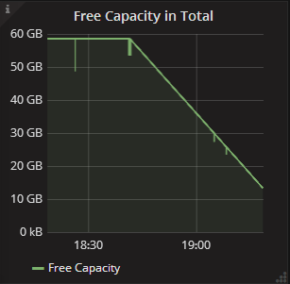

* The **Used Capacity in Total** panel (Figure 6) shows how much capacity in total is used in the Lustre filesystem. The test case used in the figure is running “dd if=/dev/zero of=/mnt/lustre/file bs=1M” from about 18:40, and it can be seen from the figure that the used capacity has increased at the rate of about 20 MB/s.

Figure : Used Capacity in Total Panel

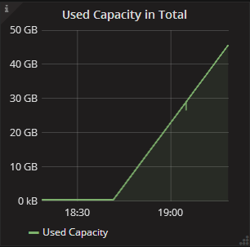

The **Free Capacity per OST** panel (Figure 7) shows how much free capacity per OST remains in the Lustre filesystem. As shown in the figure, OST0002 free capacity is 946.47MB, OST0007 free capacity is 3.59GB, the free capacity of the remaining OSTs is 4.09GB each. To display the current free capacity per OST in the ascending or descending order, click on **Current**..

Figure : Free Capacity per OST Panel

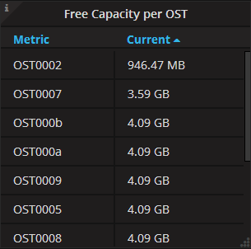

The **Used Capacity per OST** panel (Figure 8) shows how much capacity per OST is used in the Lustre filesystem. As shown in the figure, the used capacity of OST0002 is 3.97GB, the used capacity of OST0007 is 1.27GB, the used capacity of the remaining OSTs is 820.8MB. To display the current used capacity per OST in the ascending or descending order, click on **Current**.

Figure 8: Used Capacity per OST Panel

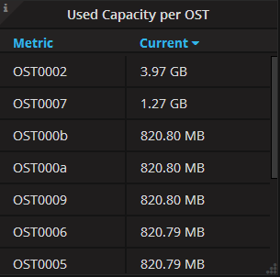

The Used Capacity per User panel (Figure 9) shows how much capacity per user is used in the Lustre filesystem. As shown in the figure, the current used capacity of the user with UID=0 is 13.65GB, the current used capacity of the user with UID=1000 is 2.10GB, the current used capacity of the user with UID=1001 is 954.37MB.

Figure 9: Used Capacity per User Panel

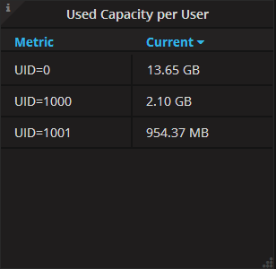

The **Used Capacity per Group** panel (Figure 10) shows how much capacity per group is used in the Lustre filesystem. As shown in the figure, the current used capacity of the group with GID=0 is 13.65GB, the current used capacity of the group with GID=1000 is 2.10GB, the current used capacity of the group with GID=1001 is 954.37MB.

Figure 10: Used Capacity per Group Panel

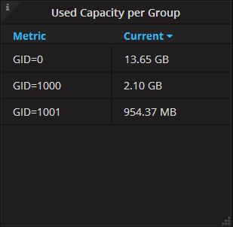

The **Free Inode Number in Total** panel (Figure 11) shows the total number of free inodes in the Lustre filesystem over time. The test case used in the figure is running“mdtest–C –n 900000 –d /mnt/lustre/mdtest/” from about 14:35. From the figure it can be seen that from that time on, the free inode number is decreased and exhausted at a speed of about 1100 Ops (Operation per Second).

Figure 11: Free Inode Number in Total Panel

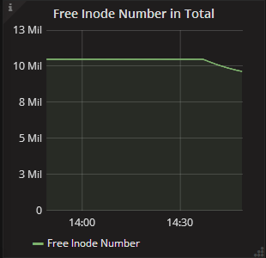

The **Used Inode Number in Total** panel (Figure 12) shows the total number of used inodes in the Lustre filesystem over time. The test case used in the figure is running “mdtest–C –n 900000 –d /mnt/lustre/mdtest/” from about 14:35, from the figure it can be seen that the used inode number is increased in a speed of about 1100 Ops (Operation per Second).

Figure 12: Used Inode Number in Total Panel

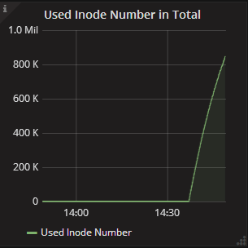

The **Free Inode Number per MDT** panel (. By clicking on the “Current”, the current free inode number per MDT in the system can be sorted in the ascending of descending order. To display the current free inode number per MDT in the ascending or descending order, click on **Current**.

**Figure 13**) shows the current number of free inodes per MDT in the Lustre filesystem. As shown in the figure, the number of free inodes of MDT0000 is 1.72Mil, the number of free inodes of all other MDTs is 2.62 Mil. By clicking on the “Current”, the current free inode number per MDT in the system can be sorted in the ascending of descending order. To display the current free inode number per MDT in the ascending or descending order, click on **Current**.

**Figure 13: Free Inode Number per MDT Panel**

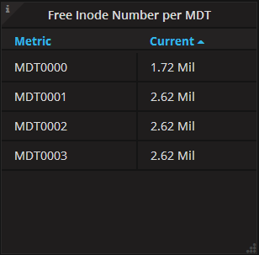

The **Used Inode Number per User** panel (Figure 14) shows the number of used inodes per user in the Lustre filesystem. As shown in the figure, the number of used nodes pertaining to the user with UID=1000 is 897.49K, the number of used inodes of the user with UID=1001 is 1.08K, the number of used inodes of the user with UID=0 is 1.01K. To display the current number of used inodes per user in the ascending or descending order, click on **Current**.

Figure 14: Used Inode Number per User Panel

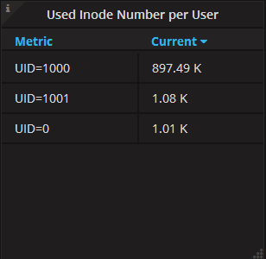

The **Used Inode Number per Group** panel (Figure 15) shows the number of used inodes per group in the Lustre Filesystem. As shown in the figure, the number of used inodes of the group with GID=1000 is 897.49K, the number of used inodes of the group with GID=1001 is 1.08K, the number of used inodes of the group with GID=0 is 1.01K. To display the current number of used inodes per group in the ascending or descending order, click on **Current**.

Figure 15: Used Inode Number Per Group Panel

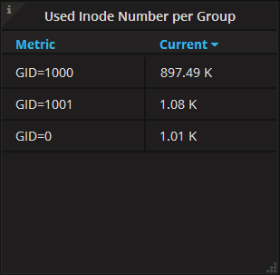

The **Used Inode Number per MDT** (Figure 16) shows the inode number per MDT used in the Lustre Filesystem. As shown in the figure, MDT0000 used inode number is 898.85K, MDT0001 is 254.

Figure 16: Used Inode Number per MDT Panel

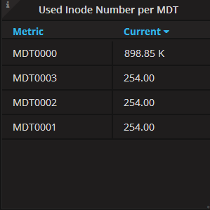

The **I/O Throughput in Total** panel (Figure 17) shows the total I/O throughput in the Lustre filesystem over time.

Figure : I/O Throughput in Total Panel

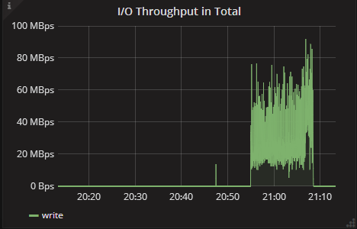

The **I/O Throughput per OST** panel (Figure 18) shows the average, maximum, and current I/O throughput per OST in the Lustre filesystem.

Figure 18: I/O Throughput per OST Panel

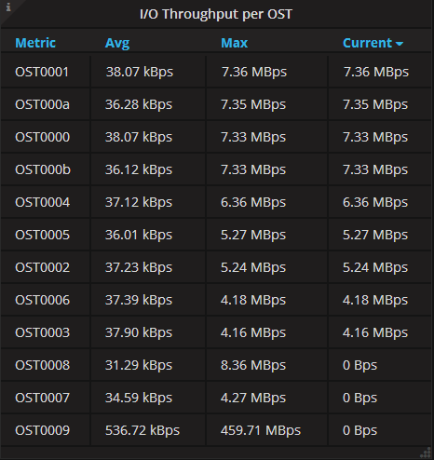

The **Write Throughput per OST** panel (Figure 19) shows the average, maximum, and current write throughput per OST in the Lustre Filesystem.

Figure 19: Write Throughput per OST Panel

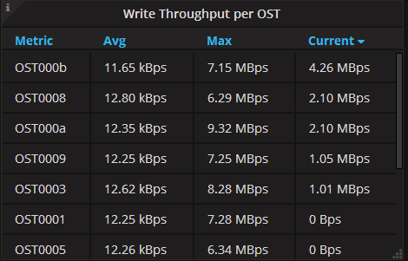

The **Read Throughput per OST** panel (Figure 20) shows the average, maximum, and current read throughput per OST in the Lustre Filesystem.

Figure 20: Read Throughput per OST Panel

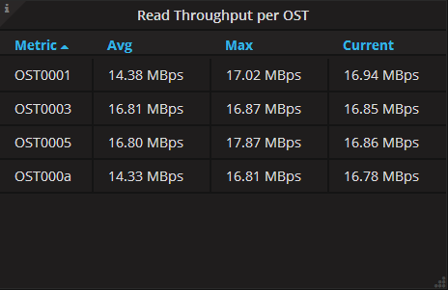

The **Metadata Operation Rate in Total** panel (Figure 21) shows the total metadata operation rate in the Lustre Filesystem over time. The unit is Ops, i.e. Operation Per Second.

Figure 21: Metadata Operation Rate in Total Panel

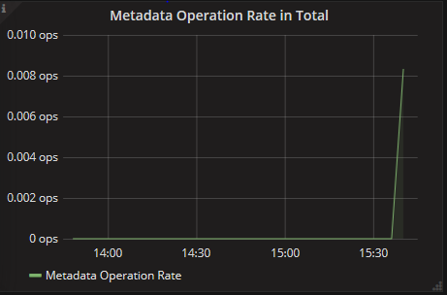

The **Metadata Operation Rate per MDT** panel (Figure 22) shows the metric information of the metadata operation rate per MDT in the Lustre filesystem. The unit is OPS (Operation Per Second). The information includes the average, maximum, and current values.

Figure 22: Metadata Operation Rate Per MDT Panel

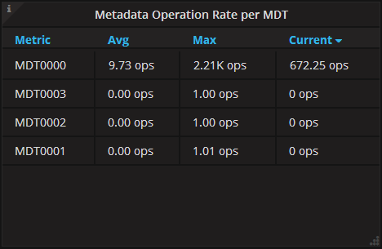

The **Metadata Operation Rate per Client** panel (Figure 23) shows the metric information of the metadata operation rate per client in the Lustre filesystem. The unit is OPS. The information includes the average, maximum, and current values.

Figure 23: Metadata Operation Rate per Client Panel

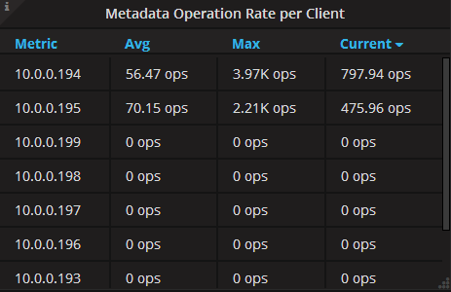

The **Metadata Operation Rate per Type** panel (Figure 24) shows the metric information of the metadata operation rate per type in the Lustre filesystem. The unit is OPS. The information includes the average, maximum, and current values. The current test case used is the operations that remove all files in a directory.

Figure 24: Metadata Operation Rate per Type Panel

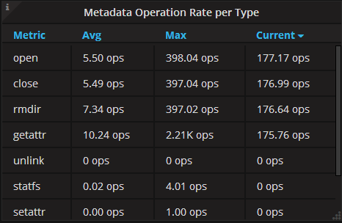

The **Write Bulk RPC Rate per Size** panel (Figure 25) shows the write bulk RPC rate with different size in the Lustre Filesystem over time. The size of Lustre Bulk RPC could be a value between 4KiB and 16MiB. The figure below shows the information of write RPC Rate with different bulk size. The test case that generated the collected information is that two clients run ”dd if=/dev/zero of=/mnt/lustre/test1 bs=1M oflag=direct”, “dd if=/dev/zero of=/mnt/lustre/test2 bs=64k oflag=direct”, respectively.

Figure 25: Write Bulk RPC Rate per Size

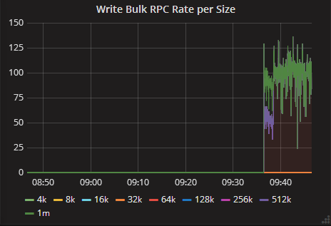

The **Size Distribution of Write Bulk RPC** panel (Figure 26) shows the ratio information of the write bulk RPC with different bulk size in the Lustre Filesystem. As shown in the figure, the percentage of total for the number of the write bulk RPC number with 256 pages is 100%.

Figure : Size Distribution of Write Bulk RPC Panel



The **Read Bulk RPC Rate per Size** panel (Figure 27) shows the read bulk RPC rate per size in the Lustre filesystem over time. The size of Lustre Bulk RPC could be a value between 4KiB and 16MiB. The figure below shows the read RPC rate with different bulk I/O size. The used test case to generate the collected information is that two clients run “dd if=/mnt/lustre/test1 of=/dev/zero bs=1M iflag=direct” and “dd if=/mnt/lustre/test2 of=/dev/zero bs=64k iflag=direct”, respectively.

Figure : Read Bulk RPC Rate per Size Panel

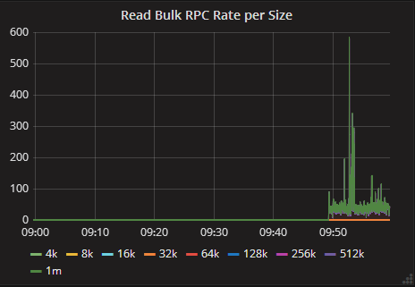

The **Size Distribution of Read Bulk RPC** panel (Figure 28) shows the ratio information of read bulk RPC with different bulk I/O size in the Lustre filesystem. As shown in the figure, the total percentage of the read bulk RPC number with 256 pages is 100% where the current used test case is running”dd if=/mnt/lustre/file of=/dev/zero bs=1M”.

Figure : Size Distribution of Read Bulk RPC Panel



In each Lustre I/O, if the next page to be written or read in the I/O is not with the next offset, that page is a discontinuous page. There could be multiple discontinuous pages in an I/O. I/Os with less discontinuous pages are more friendly to OSTs, and underlying disk system will obtain much better performance. The **Distribution of Discontinuous Pages in Each Write I/O** panel (Figure 29) shows the ratio information of the discontinuous pages in each write I/O in the Lustre filesystem. As shown in the figure, the total percentage of discontinuous pages “0_pages” is 100%, which means all pages are continuous.

Figure 29: Distribution of Discontinuous Pages in Each Write I/O Panel



The **Distribution of Discontinuous Pages in Each Read I/O** panel (Figure 30) shows the ratio information of discontinuous pages in each read I/O in the Lustre filesystem. As shown in the figure, the percentage of discontinuous pages “0_pages” in each read I/O is 100%, which means all pages are continuous.

Figure 30: Distribution of Discontinuous Pages in Each Read I/O Panel



The **Distribution of Discontinuous Blocks** panel (Figure 31) shows the ratio information of the discontinuous blocks in each write I/O in the Lustre filesystem. In each Lustre read/write I/O, the meaning of discontinuous blocks is similar to discontinuous pages. How many pages a block contains is determined by the underlying filesystem (ldiskfs).If an I/O has discontinuous blocks, there must exist discontinuous pages, but the opposite is not necessarily true. As shown in the figure, the percentage of write discontinuous blocks “0_blocks” in each write I/O is 100%, which means nearly all write I/O are continuous.

Figure 31: Distribution of Discontinuous Blocks in Each Write I/O Panel

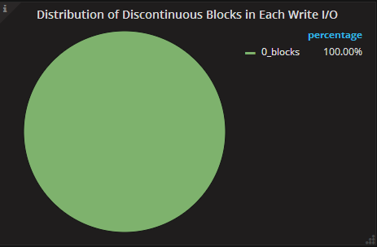

The **Distribution of Discontinuous Blocks in Each Read I/O** panel (Figure 32) shows the ratio information of discontinuous blocks in each read I/O in the Lustre filesystem. As shown in the figure, the percentage of discontinuous blocks “0_blocks” in each read I/O is 100%, and it means that none of the read I/Os is discontinous.

Figure 32: Distribution of Discontinuous Blocks in Each Read I/O Panel

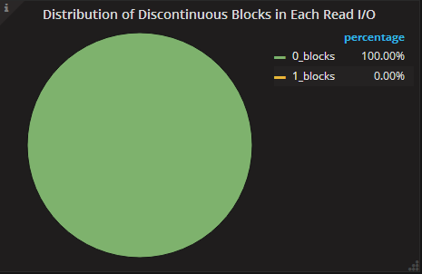

For various reasons (e.g. too many pages to read or write per single I/O), read or write I/O sent by Lustre OSD to the underlying disk system may be split into multiple disk I/Os. The **Distribution of Fragments in Each Write I/O** panel (Figure 33) shows the distribution of write I/Os by the number of disk I/Os each write I/O is split into. As shown in the figure, “1_fragments” denotes that I/O is not split. The percentage of “1_fragments” is 100%, which means that none of the write I/O is split and all of them are continuous. “2_fragments” denotes that Lustre write I/O is split into two disk block I/Os, and the percentage in the figure is 0%.

Figure 33: Distribution of Fragments in Each Write I/O Panel

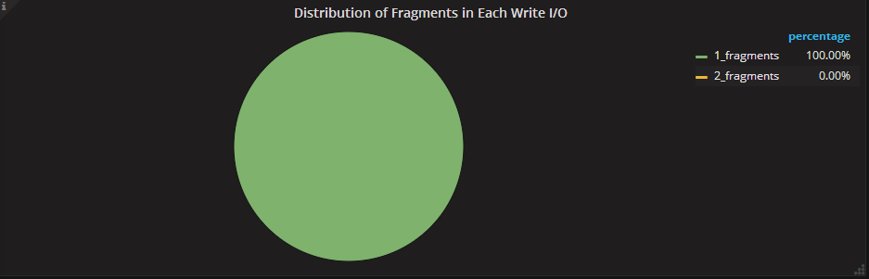

The **Distribution of Fragments in Each Read I/O** panel (Figure 34) shows the distribution of read I/Os by the number of disk I/Os each read I/O is split into. In the figure, the percentage of “1_fragments” is 100%, which means that none of the read I/Os is split and all of them are continuous. “2_fragments” denotes that Lustre read I/O is split into two disk block I/Os, and the percentage in the figure is 0%.

Figure 34: Distribution of Fragments in Each Read I/O Panel

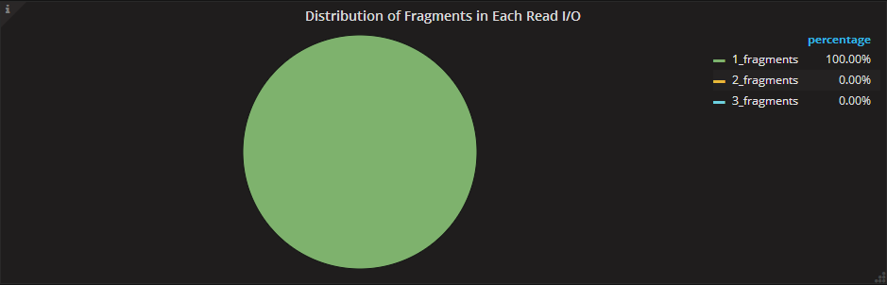

The **Distribution of in-flight Write I/O Number when Starting Each Write I/O** panel (Figure 35) shows the distribution of the number of write I/Os operations pending at the time of starting each write I/O in the Lustre filesystem. In the figure, ”1_ios” has percentage of 100%. That means, when the write I/O operations started on the OST, this I/O was the only one write I/O that is currently being submitted to disk.

Figure 35: Distribution of in-flight Write I/O Number when Starting Each Write I/O Panel

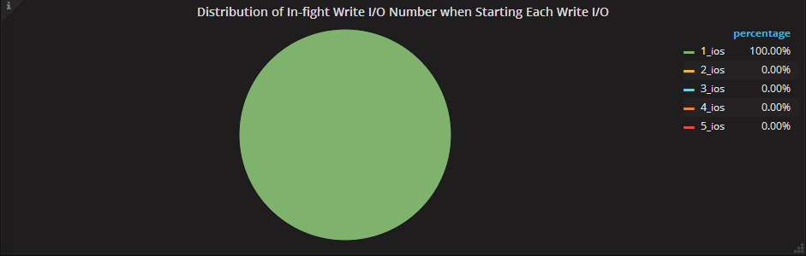

The **Distribution of in-flight Read I/O Number when Starting Each Read I/O** panel (Figure 36) shows the distribution of the number of read I/Os operations pending at the time of starting each read I/O in the Lustre filesystem. For example, “4_ios” has percentage of 49.80% in the figure. That means 49.80% of the read I/O operations started when there were four in-flight I/O operations on that OST.

Figure 36: Distribution of in-flight Read I/O Number when Starting Each Read I/O Panel

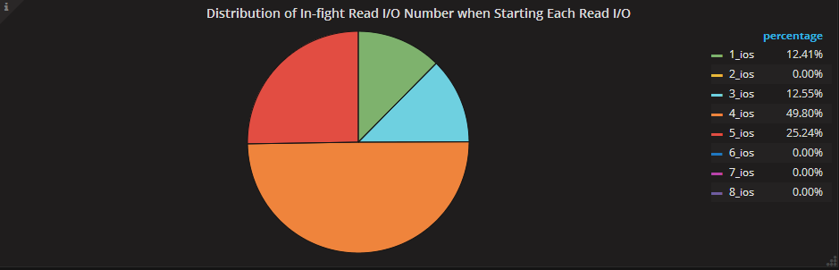

The **Distribution of Write I/O Time** panel (Figure 37) shows the current distribution of OSD write I/O time in the Lustre filesystem. “1_milliseconds” represents the percentage of I/O operations whose duration is less than 1 millisecond, “2_milliseconds” represents the percentage of I/O operations whose duration is between 1 millisecond and 2 milliseconds, and so on.

Figure 37: Distribution of Write I/O Time Panel

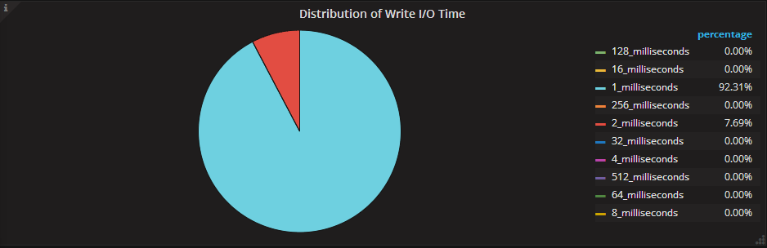

The **Distribution of Read I/O Time** panel (Figure 38) shows the current distribution of OSD write I/O size in the Lustre filesystem. In the figure, the percentage of “1_milliseconds” I/Os (I/Os whose duration is less than 1 millisecond) is 14.11%, “4K_milliseconds” I/Os (I/Os whose duration is between 2K milliseconds and 4K milliseconds) take up 42.62%.

Figure 38: Distribution of Read I/O Time Panel

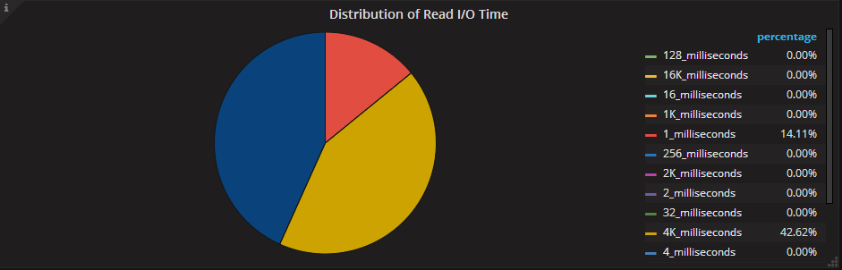

The **Distribution of Write I/O size on Disk** panel (Figure 39) shows the current distribution of OSD write I/O size in the Lustre filesystem. In the panel, “1M_Bytes” represents disk I/Os that have sizes between 512K and 1M bytes, “512K_Bytes” represents I/Os with disk I/O size between 256K and 512K bytes, etc.

Figure 39: Distribution of Write I/O size on Disk Panel

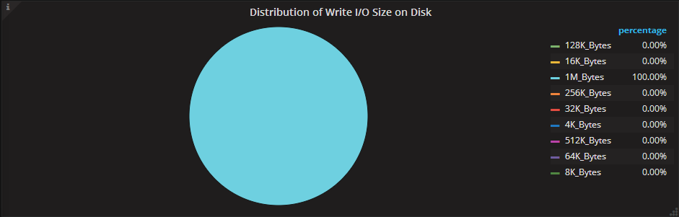

The **Distribution of Read I/O Size on Disk** panel (Figure 40) shows the distribution of OSD read I/O size in the Lustre filesystem. In the panel, “1M_Bytes” represents I/Os with disk I/O size between 512K and 1M bytes, “512K_Bytes” represents I/Os with disk I/O size between 256K and 512K bytes, etc. In the figure, the percentage of “1M_Bytes” I/Os is 94.16% and the percentage of “512K_Bytes” I/Os is 5.84%.

Figure 40: Distribution of Read I/O Size on Disk Panel

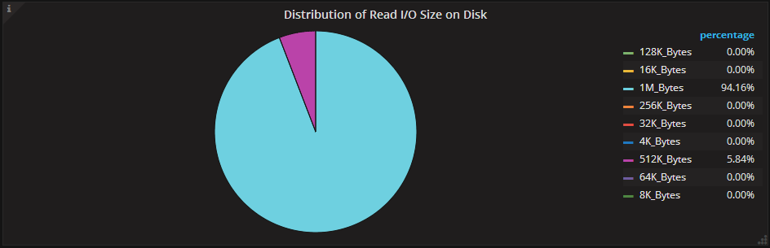

The **Write Throughput per Client** panel (Figure 41) shows the average, max, and current write throughput per client in the Lustre filesystem. As shown in the figure, the average/max/current values of the write throughput for the client with the IP address 10.0.0.195 are 14.71MBps/55.73MBps/42.62MBps, respectively.

Figure 41: Write Throughput per Client Panel

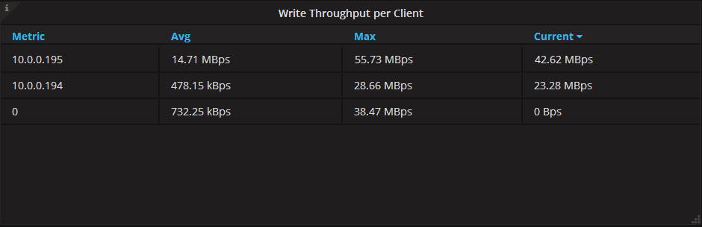

The **Read Throughput per Client** panel (Figure 42) shows the metric information of the read throughput per client in the Lustre filesystem. It includes average, max, and current values. As shown in the figure, the average, max, and current values of the read throughput for the client with the IP address 10.0.0.194 are 32.01MBps/55.71MBps/23.50MBps.

Figure 42: Read Throughput per Client Panel

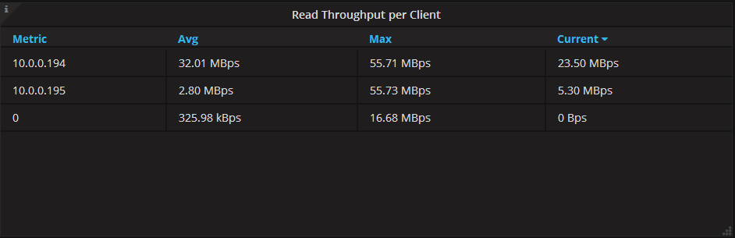

The **I/O Throughput per Job** panel (Figure 43) shows the metric information of the I/O throughput per job in the Lustre filesystem. It includes average, max, and current values. As shown in the figure, for the job with JOBID “dd.0”, the average I/O throughput is 7.68MBps, the max value is 65.16MBps, and the current I/O throughput is 29.37MBps.

Figure 43: I/O Throughput per Job Panel

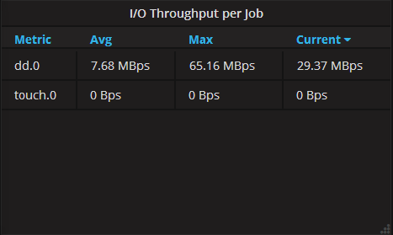

The **Write Throughput per Job** panel (Figure 44) shows the metric information of the write throughput per job in the Lustre filesystem. It includes average, max, and current values. As shown in the figure, for the job with JOBID “dd.0”, the average I/O throughput is 7.68MBps, the max value is 64.16MBps, and the current I/O throughput is 29.37MBps.

Figure 44: Write Throughput per Job Panel

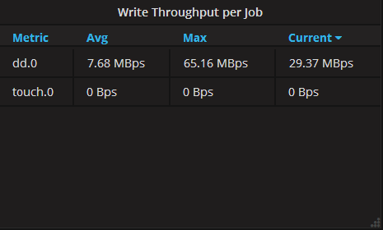

The **Read Throughput per Job** panel (Figure 45) shows the metric information of the read throughput per job in the Lustre filesystem. It includes average, max, and current values. As shown in the figure, for the job with JOBID “dd.0”, the average I/O throughput is 2.56MBps, the max value is 59.79MBps, and the current I/O throughput is 12.75MBps.

Figure 45: Read Throughput per Job Panel

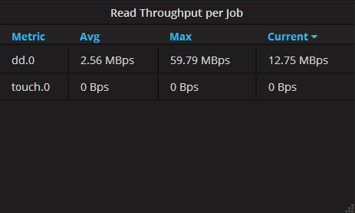

The **Metadata Performance per Job** panel (Figure 46) shows the metric information of the metadata performance per job in the Lustre filesystem. It includes average, max, and current values, and the unit is OPS (Operations per Second). As shown in the figure, for the job with JOBID “rm.0”, the average metadata performance is 94.42 ops, max value is 1.19K ops, and the current performance is 7.00 ops.

Figure 46: Metadata Performance per Job Panel

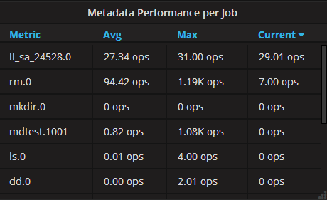

## Server Statistics

The Server Statisticsdashboard (Figure 47) shows detailed information about a server.

Figure : Server Statistics Dashboard

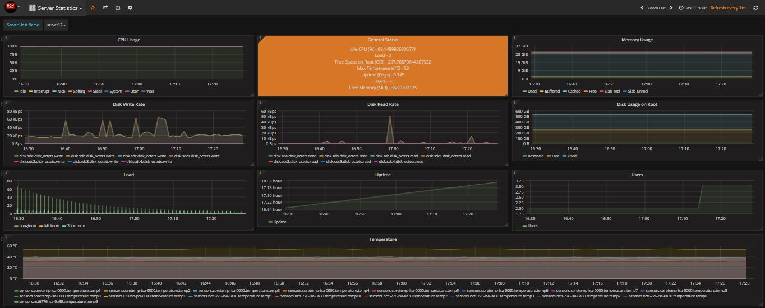

Below you will find description of some of the panels in the **Server Statistics** dashboard:

* The **CPU Usage** panel (Figure 48) shows the amount of time spent by the CPU in various states, most notably executing user code, executing system code, waiting for IO-operations and being idle.

Figure : CPU Usage Panel

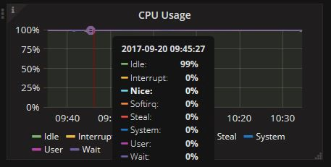

* The **Memory Usage** panel (Figure 49) shows how much memory has been used. The values are reported by the operating system. The categories are: **Used**, **Buffered**, **Cached**, **Free**, **Slab_recl**, **Slab_unrecl**.

Figure : Memory Usage Panel

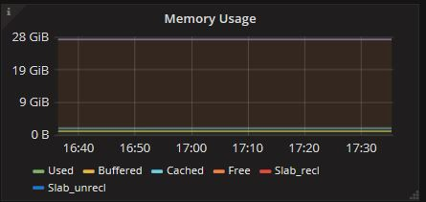

* The **Disk Write Rate** panel (Figure 50) shows the disk write rate of the server.

Figure : Disk Write Rate Panel

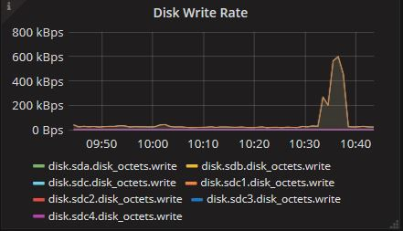

* The **Disk Read Rate** panel (Figure 51) shows the disk read rate of the server.

Figure : Disk Read Rate Panel

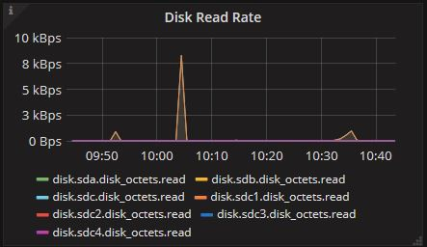

* The **Disk Usage on Root** panel (Figure 52) shows free space, used space and reserved space on the disk that is mounted as Root.  
  A warning message will be generated when there’s little free space left.

Figure : Disk Usage on Root Panel

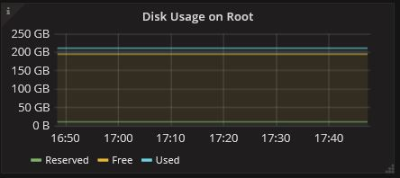

* The **Load** panel (Figure 53) shows the load on the server. The system load is defined as the number of runnable tasks in the run-queue and is provided by many operating systems as follows:
  + **Shortterm**— one minute average
  + **Midterm**— five minutes average
  + **Longterm**— fifteen minutes average

Figure : Load Panel

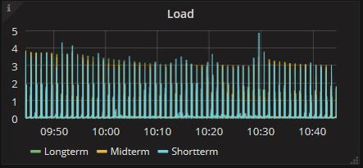

* The **Uptime** panel (Figure 54) shows how long the server has been working. It keeps track of the system uptime, providing such information as the average running time or the maximum reached uptime over a certain period of time.

Figure : Uptime Panel

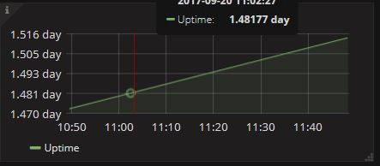

* The **User** panel (Figure 55) shows the number of users currently logged into the system.

Figure : User Panel

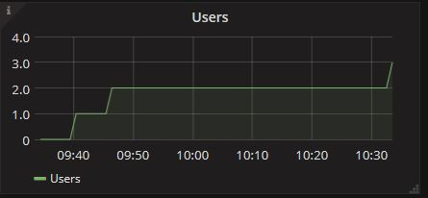

* The **Temperature** panel (Figure 56) shows the temperature collected from sensors.

Figure : Temperature Panel

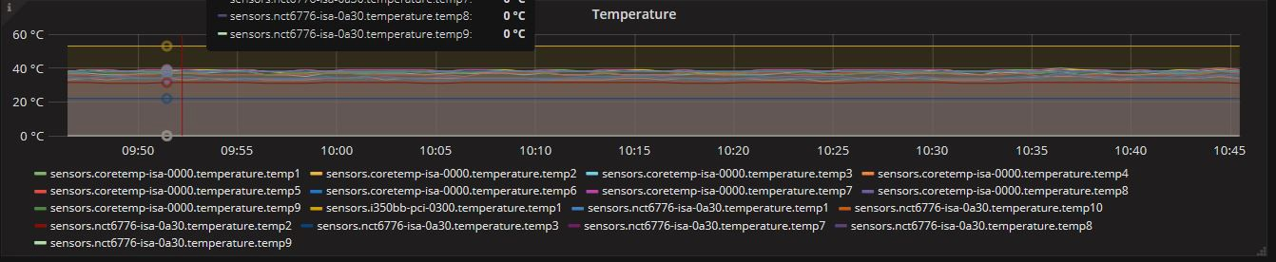

## SFA Physical Disk Dashboard

The **SFA Physical Disk** dashboard shown in Figure 57 displays information about DDN SFA physical disks.

Figure : SFA Physical Disk Dashboard

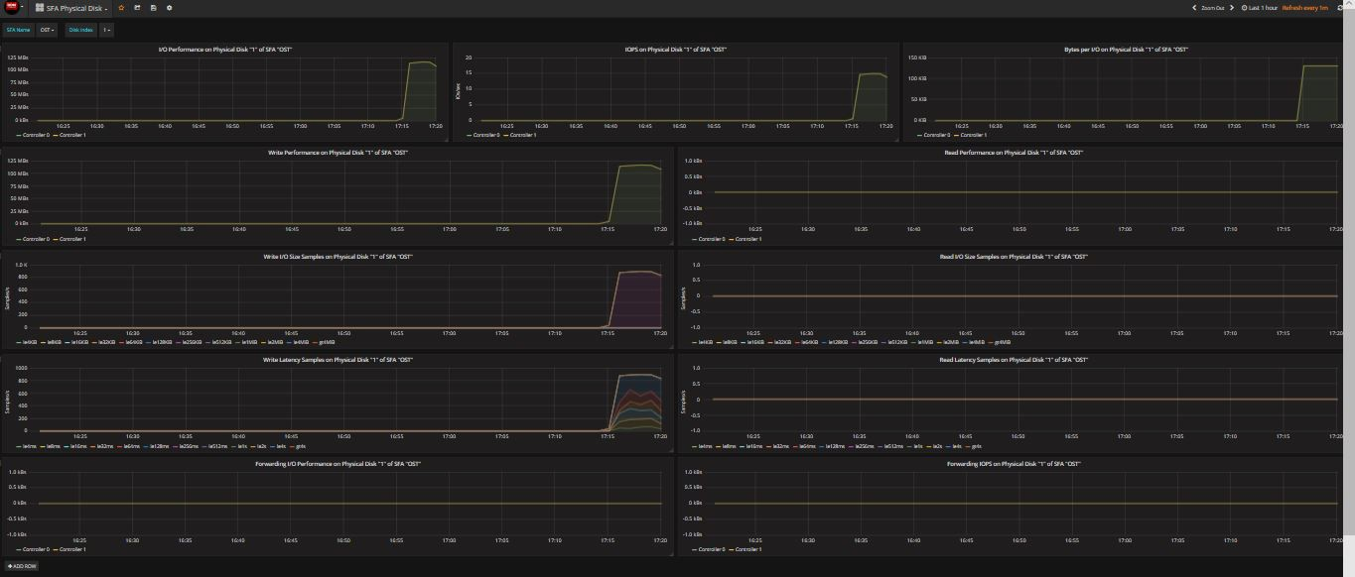

Below you will find description of some of the panels in the **SFA Physical Disk** dashboard:

* The **I/O Performance on Physical Disk** panel (Figure 58) shows I/O speed over time.

Figure : I/O Performance on Physical Disk Panel

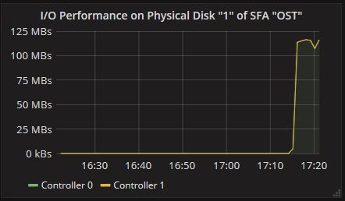

* The **IOPS on Physical Disk** panel (Figure 59) shows I/O operations per second on Physical Disk.

Figure : IOPS on Physical Disk Panel

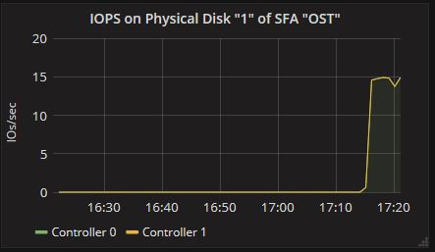

* The **Bytes per I/O** panel (Figure 60) shows the I/O bytes per second on each controller.

Figure : Bytes per I/O on Physical Disk Panel

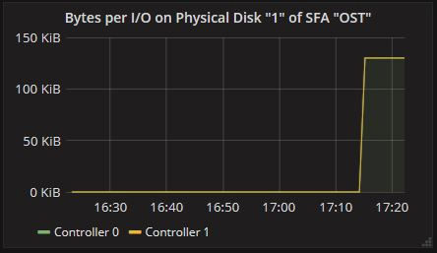

* The **Write Performance** panel (Figure 61) shows the write performance on each controller.

Figure : Write Performance on Physical Disk Panel

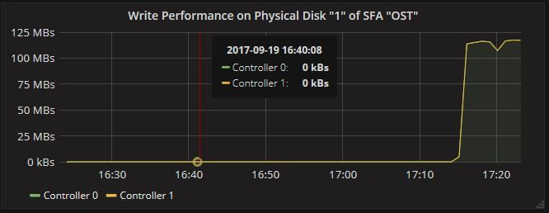

* The **Write I/O Size Samples** panel (Figure 62) shows the account of writting operation on each size.

Figure : Write I/O Size Samples on Physical Disk Panel

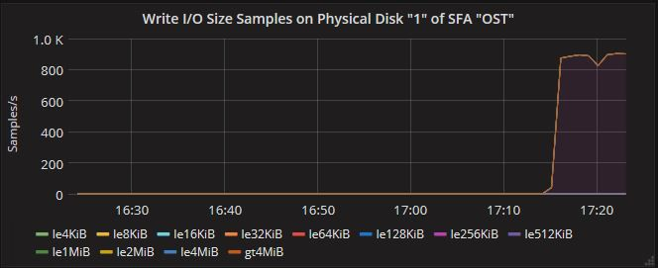

* The **Write Latency Samples** panel (Figure 63) shows the account of writing operation on each latency.

Figure : Write Latency Samples on Physical Disk Panel

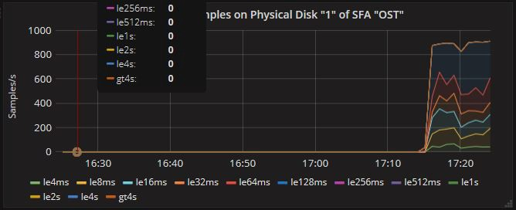

## SFA Virtual Disk Dashboard

The **SFA Virtual Disk** dashboard (Figure 64 ) shows information about DDN SFA virtual disks:

Figure : SFA Virtual Disk Dashboard

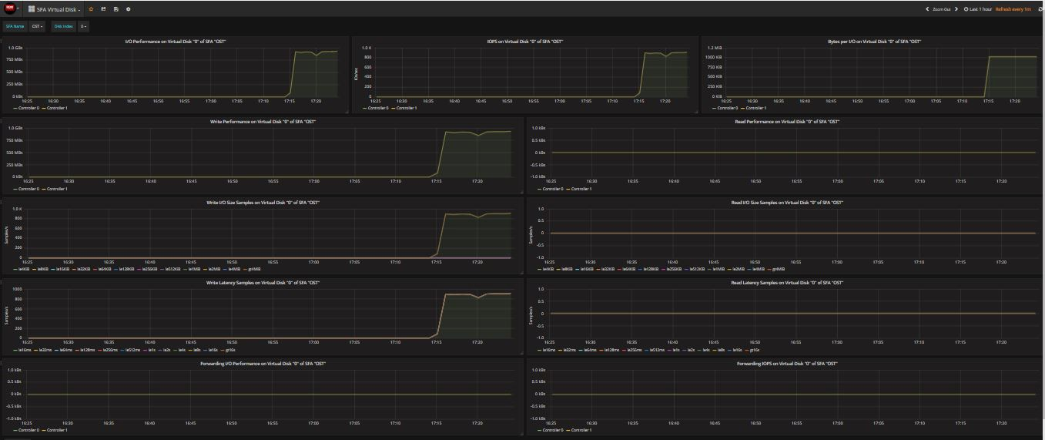

Below you will find description of some of the panels in the **SFA Virtual Disk** dashboard:

* The I/O Performance panel (Figure 65) in shows the I/O speed at a specific time.

Figure : I/O Performance on Virtual Disk Panel

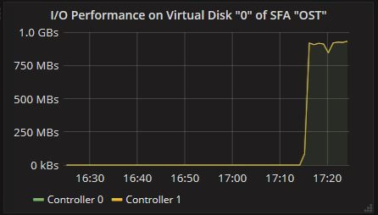

* The IOPS panel (Figure 66) shows I/O operations per second on Virtual Disk.

Figure : I/O Operations per Second on Virtual Disk Panel

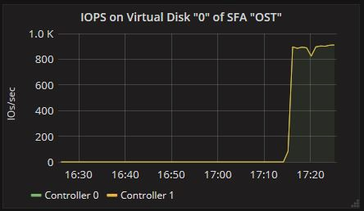

* The Bytes per I/O panel (Figure 67) shows I/O bytes per second on each controller.

Figure : Bytes per I/O on Virtual Disk Panel

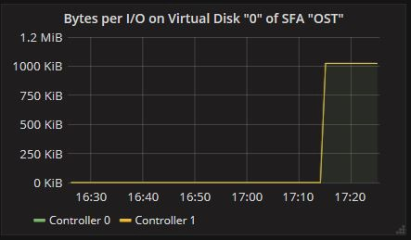

* The Write Performance panel (Figure 68) shows write performance on each controller.

Figure : Write Performance on Virtual Disk Panel

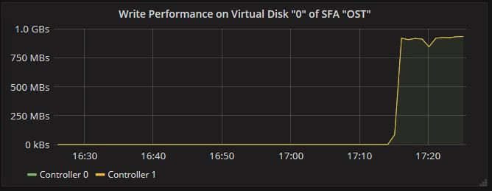

* The Write I/O Size Samples panel (Figure 69) shows the size distributions of write I/Os.

Figure : Write I/O Size Samples on Virtual Disk Panel

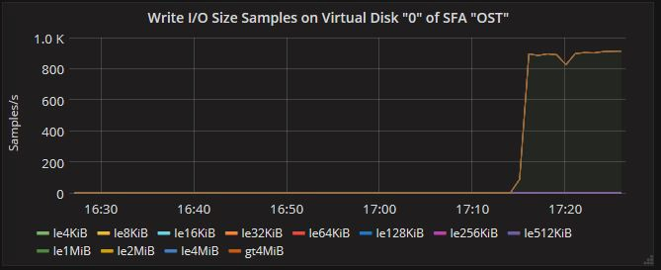

* The Write Latency Samples panel (Figure 70) shows the latency distributions of write I/Os.

Figure : Write Latency Samples on Virtual Disk Panel

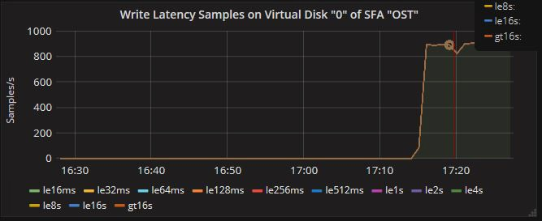

# Stress Testing

In order to check whether the monitoring system works well under high pressure, DDN designed the **collectd-stress2** plugin for stress testing. It is an upgraded version of the **Stress** plugin, which can use a couple of **collectd** clients to simulate tens of thousands of metrics collected from hundreds of servers.

## Installing stress2 RPM on collectd Client

Because the **stress2** plugin generates a large amount of simulated monitoring data and contaminates the database, the plugin should not be installed on all clients by default. After the monitoring system has been installed using esmon_install, select a couple of **collectd** clients as testing hosts and install the **stress2** plugins on each of the testing hosts. The RPM collectd-stress2 * .rpm should be located in the ISO directory. To install the RPM, run the following command:

rpm --ivh collectd-stress2*.rpm

## Updating Configuration File of Collectd Client

After **stress2** RPMs have been installed, update the configuration file /etc/collectd.conf and add the following configuration:

* **Thread** —Defines the number of test threads.
* **Metric** — Defines all the attributes of the monitoring target. It can be specified multiple times to simulate different monitoring targets at the same time. It contains the following attributes:
  + **Variable** — Defines the scope of the monitoring target changes and the speed of change, it can be specified multiple times.
    - **Name** — Defines the variable name.
    - **Number** — Defines the maximum range of variable changes.
    - **UpdateInterval** — Defines the time interval between variable changes.
  + **Host**—Defines the host name of the client, usually defined as "$ {key: hostname}", the program automatically sets the current host name. It describes the discriminator of the collection data object together with the following **Plugin**, **PluginInstance**, **Type**, **TypeInstance**. See [Naming Schema](https://collectd.org/wiki/index.php/Naming_schema) for details.
  + **Plugin**—Defines the plugin member in the collectd identifier.
  + **PluginInstance**—Defines the plugininstance member in the collectd identifier.
  + **Type**—The type member of the collectd identifier. For details, see <https://collectd.org/wiki/index.php/Derive>.
  + **TypeInstance**—Defines the type instance member in the collectd identifier.
  + **TsdbName**—Defines the name submitted to the database format.
  + **TsdbTags**—Defined the tags submitted to the database format to facilitate the late classification search.

Below is an example of /etc/collectd.conf.

**Example:**

LoadPlugin stress2

<Plugin "stress2">

  Thread 32

  <Metric>

<Variable>

    Name "ost_index"

    Number 10

    UpdateIterval 0

</Variable>

<Variable>

    Name "job_id"

    Number 7000

    UpdateIterval 10

</Variable>

  Host "${key:hostname}"

  Plugin "stress-${variable:ost_index:OST%04x}"

  PluginInstance "jobstat_${variable:job_id:job%d}"

  Type "derive"

  TypeInstance "sum_read_bytes"

  TsdbName "ost_jobstats_samples"

  TsdbTags "optype=sum_read_bytes fs_name=stress ost_index=${variable:ost_index:OST%04x} job_id=${variable:job_id:job%d}"

   </Metric>

  <Metric>

<Variable>

    Name "mdt_index"

    Number 10

    UpdateIterval 0

</Variable>

<Variable>

    Name "md_stats"

    Number 10

    UpdateIterval 10

</Variable>

  Host "${key:hostname}"

  Plugin "stress-${variable:mdt_index:MDT%04x}"

  PluginInstance "md_stats"

  Type "derive"

  TypeInstance "open"

  TsdbName "md_stats"

  TsdbTags "optype=open fs_name=stress mdt_index=${variable:mdt_index:MDT%04x} mdt_stats_open=${variable:mdt_stats_open:%d}"

   </Metric>

</Plugin>

## Start Testing

After modifying the configuration file, restart collectd:

service collectd restart

A message like the following should appear in */var/log/messages*:

server11 collectd[20830]: stress2: time: 1.79244 for 70100 commits with 32 threads, 39108.70099 commits/second

The above information shows that stress2 plugin successfully loaded , and generated a lot of monitoring data. With the above configuration file and following specified hardware environment, the corresponding monitoring bottlenecks were checked.

* **OS：**CentOS7.
* **Memory：**128GB.
* **CPU:** Intel(R) Xeon(R) CPU E5-2630 v3 @ 2.40GHz.
* **Disk:** Samsung SSD 850 2B6Q.

The monitoring client and database server are running on the same host, Influxdb data is stored on SSD with ext4 file system.

**Preconditions:**

* **Collectd Interval:** 60 seconds.
* **Grafana History:** 1 hour.
* **Grafana Refresh Interval:** 60 seconds.
* **Collectd Running Time:** more than 1 hour.

**Conclusion:**

* **Grafana keeps on refreshing:** monitor overload.
* **Grafana has idle time:** monitor running well.

In theory, Grafana's refresh time equals the database query time plus the web page load time.

We can query the database to measure the performance of the database query. For example the following is the default query command for ES PERFMON Grafana **Read Throughput per Job**:

influx -database esmon_database –execute \

"SELECT "value" FROM "ost_jobstats_samples" WHERE ("optype" = 'sum_read_bytes' AND "fs_name" = 'stress') AND time >= now() - 1h GROUP BY "job_id""

With the monitoring software running, the above command on the database host can be executed to verify the query time. As shown in Figure 71, the query time of the Influxdb grew linearly during the first hour, because the data points kept on accumulating . But after an hour, the query time became steady, which is also expected behavior.

Figure 71：Influxdb Query Time

After verifying the load on the database side, we also need to verify the loading status of Grafana. Log in to Grafana to see **Read Throughput per Job** (see Figure 72)

Figure 72：Read throughput per Job stress testing

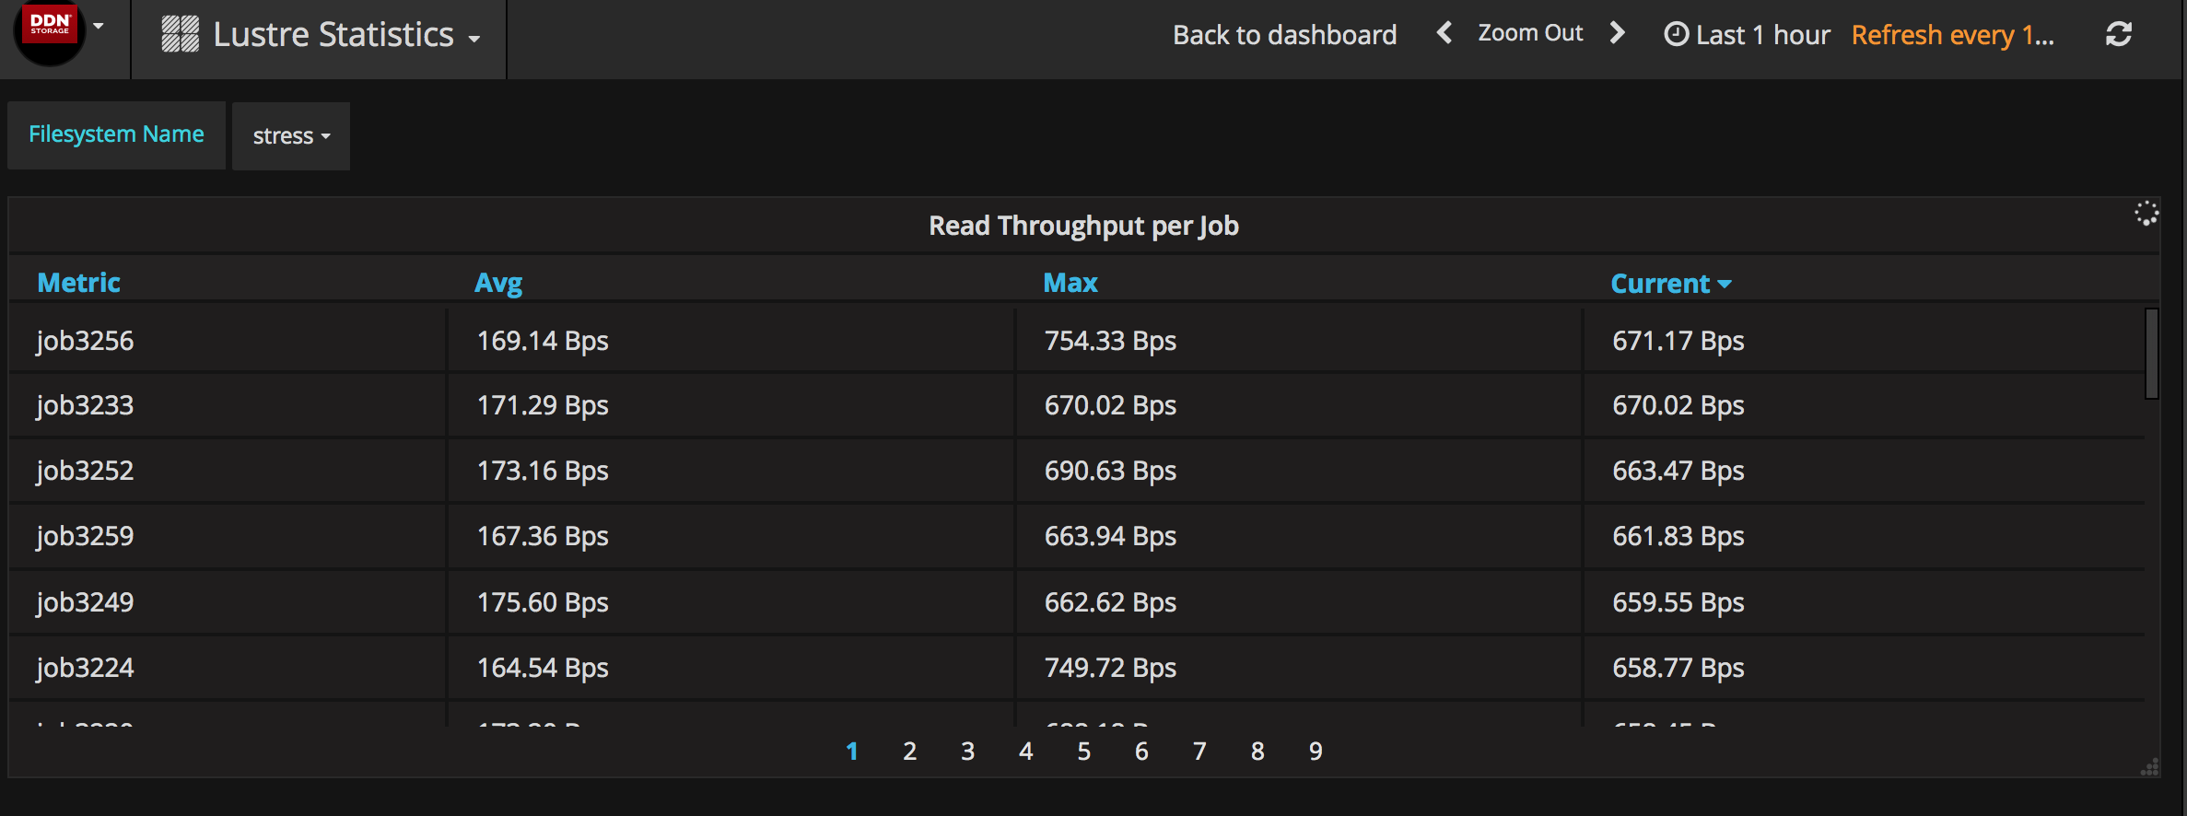

If the page is always refreshing and the page can be loaded within 60 seconds, that means, under the current configuration, the monitoring system can handle the current pressure. Otherwise, the monitoring system can be considered overloaded. In that case, either hardware need to be upgraded or the data collecting/refreshing intervals need to be increased. By continuously adjusting the number of **job_id** in */etc/collectd.conf* and checking the page refreshing latency, the maximum supported metrics can be known under the current hardware configuration. Tests show that if Lustre has 10 OSTs, with above hardware, the monitoring system can support up to 7000 running jobs at the same time without any problem.

# Troubleshooting

The directory */var/log/esmon_install/[installing_date]* on the Installation Servergathers all the logs that is useful for debugging. If a failure happens, some error messages will be written to the file */var/log/esmon_install/[installing_date]/error.log*. The first error message usually contains the information about the cause of failure.